

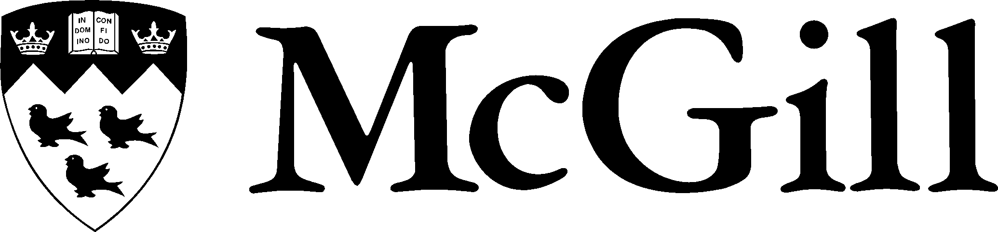

**MIME 262 Study Guide**



MIME 262 is a course which introduces electrical engineering students to a variety of topics in material science. This study guide is intended to help you succeed in this course and have a decent understanding of the basics of material science.

Recommended study time per week: 2 hours for problem solving and 4 hours for text reading.

The following subjects are ranked in terms of their helpfulness for studying and preparing for the exams. The ordering is done based on the past experience of a student who took the course in fall 2018 with Professor Quitoriano.

**PAST LECTURE NOTES**

Personally, I felt this was very helpful in terms of preparing for the weekly quizzes. These notes made it much easier for me to understand the course material because of how straightforward they are. I also made my own set of notes by reading the course text and the past lecture notes. This process of generalizing and summarizing is most helpful when it comes to studying.

**LECTURES**

I would rank lectures as the second most helpful resource. The lectures were helpful in terms of pointing out the “must know” concepts. It helped me prioritize concepts and course materials so that I won’t be studying the wrong thing.

**HOMEWORK PROBLEMS**

The homework problems were quite helpful: it gave me an idea of how the questions were going to be asked on exams and quizzes. Sometimes it helped me understand concepts. Nonetheless, these problems test basic understanding. It is very important to identify what concepts each problem is testing and how you should approach and solve it.

**TUTORIALS**

In my opinion, the tutorials went a bit fast in terms of pace. It was helpful when I already had a basic idea of the materials discussed in lectures. I would recommend going only if you’ve already attempted the problem set and are looking for explanations, etcetera.

**COURSE READINGS**

The course readings are most comprehensive in terms of content. However, this took up most of my time and required a good amount of effort. The work paid off during the midterm and finals, but in terms of weekly quizzes, I would say the past lecture notes were much more helpful.